**CSYE-7245 Final Project** Bhumika Punjabi, NUID- 001061256

# **Serverless FastAPI with AWS Lambda and API Gateway**

The Serverless FastAPI will be ran on an AWS Lambda by using Mangum and AWS API Gateway will handle routing all requests to the Lambda.

API Gateway uses wildcard for an endpoint and redirect to the FastAPI Lambda and internally route the request accordingly. This way the only cost incurred is whenever there is a request made to the API.

Mangum allows to wrap the API with a handler that we will package and deploy as a Lambda function in AWS. Then using AWS API Gateway we will route all incoming requests to invoke the lambda and handle the routing internally within our application.

### Requirements

* Python
* Virtualenv
* AWS Account

### **Virtualenv**

First you need to create and activate your virtual environment.

### **Setup Virtual Environment**

Once you have Virtualenv installed, create a new folder.

**mkdir serverless-fastapi**

Then cd into it.

**cd serverless-fastapi**

Running the following command will create a new folder in the root of your project where all of the dependencies of the app will be stored.

**virtualenv -p python3.7 env**

Then set your terminal to reference the virtual environment.

**source ./env/bin/activate**

### Dependencies

Now that the virtual environment is setup we can install some dependencies which will be FastAPI, Uvicorn and Mangum

**pip install fastapi[all] uvicorn**

### **pip install mangum**

## Create FastAPI SEVIR App

### File Tree is as follows:

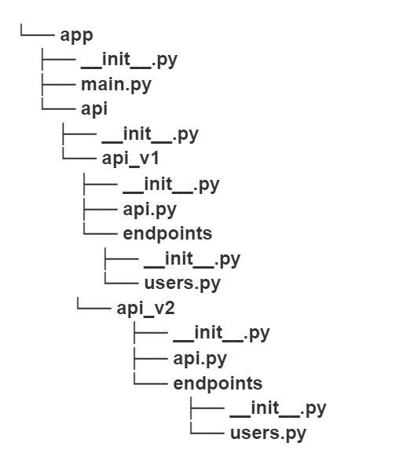

Add main.py File

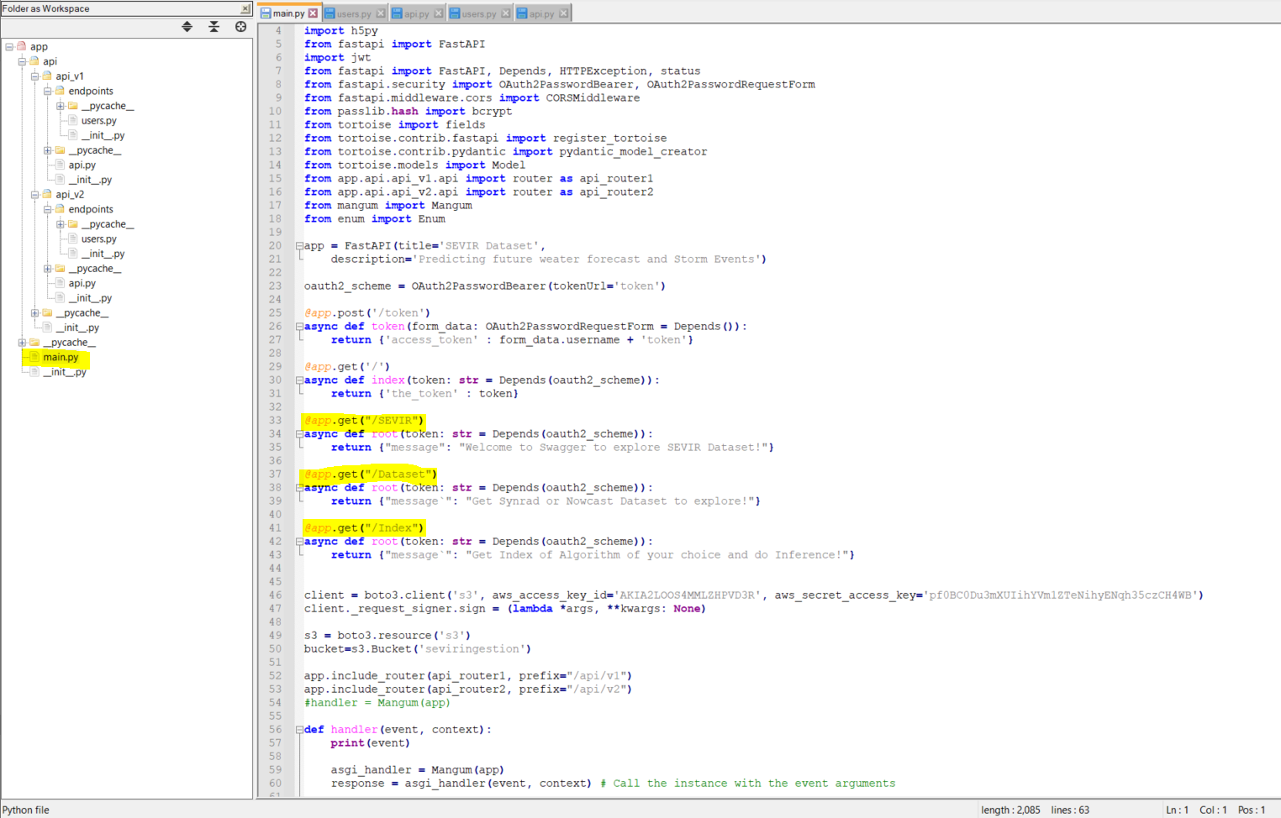

### Add Another Route

**Nowcast FastApi**

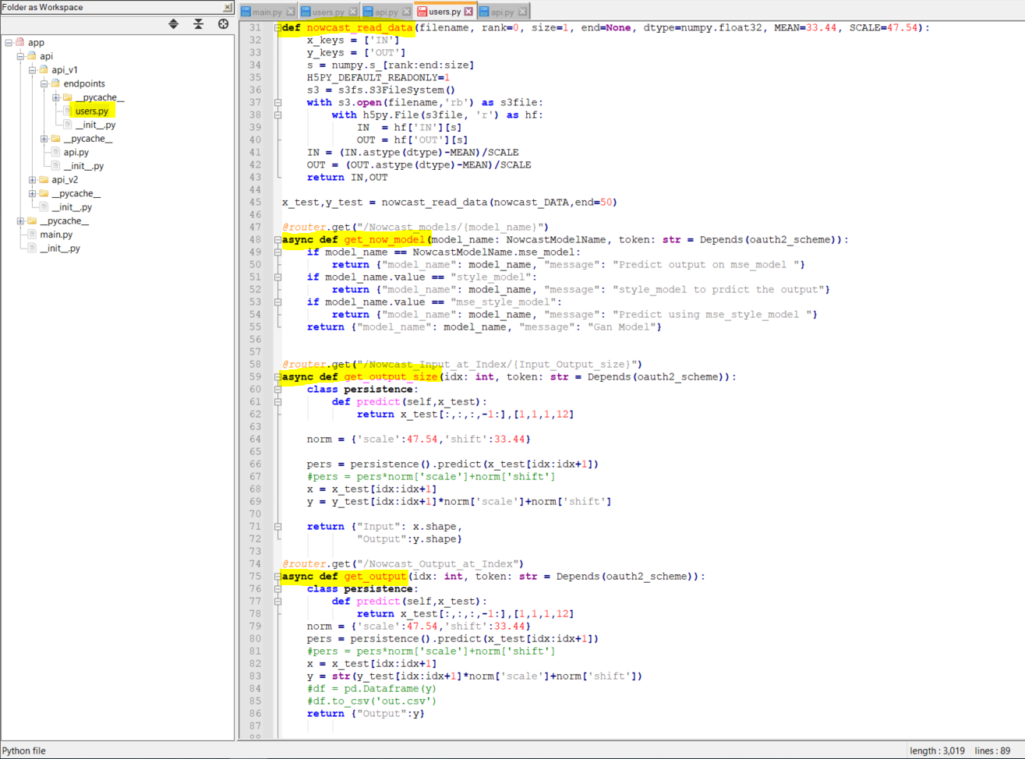

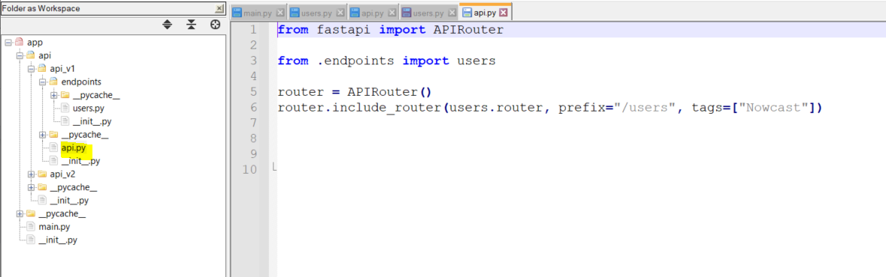

**Synrad FastApi**

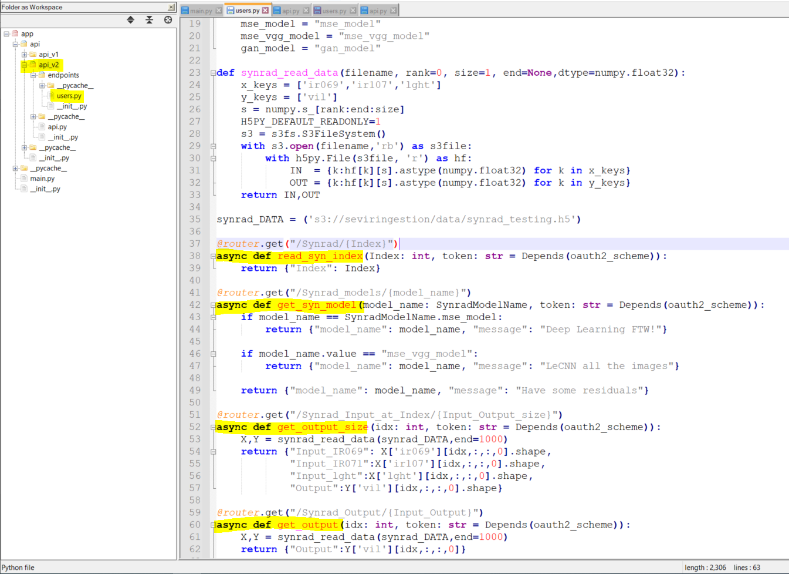

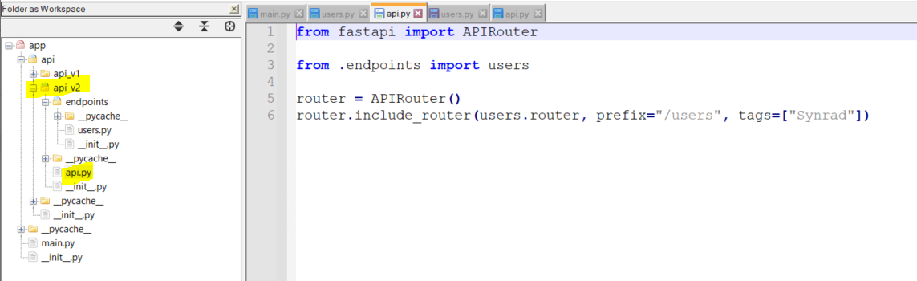

Run FastAPI

**uvicorn app.main:app --reload**

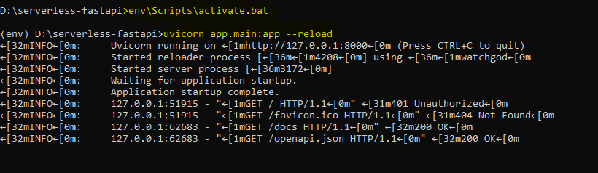

Test it locally**- http://127.0.0.1:8000/docs**

## 

# FastAPI Authentication

## Implemented With OAuth2, used JSON web tokens (JWT) for the token in the OAuth flow

At First Authorize by generating Token-

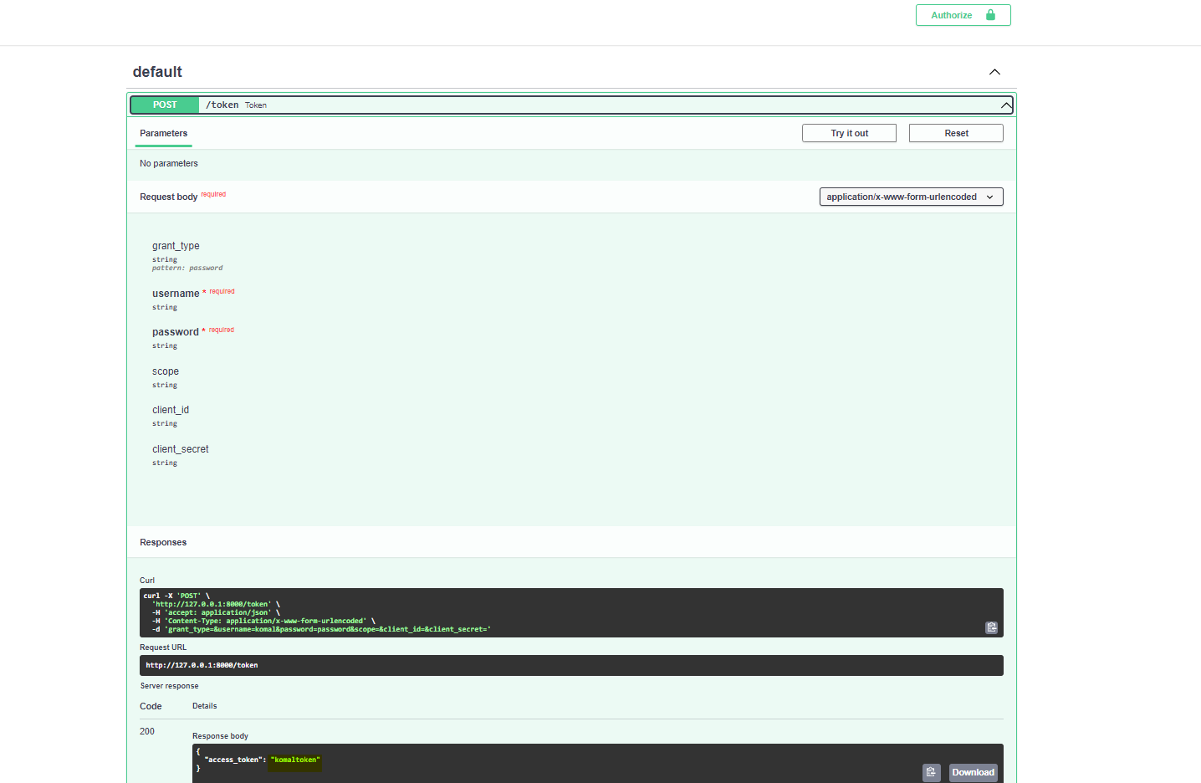

Unlock it with the generated token.

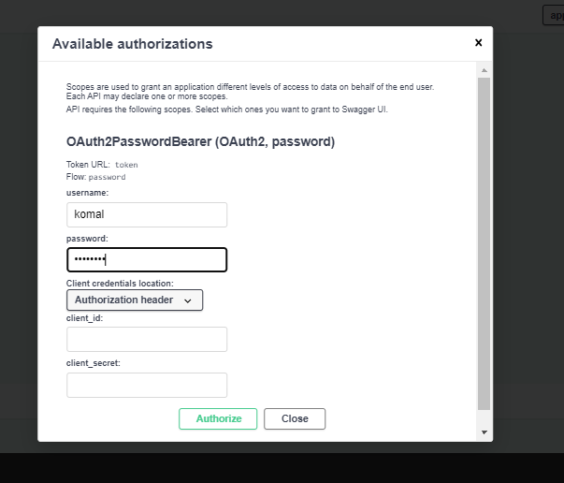

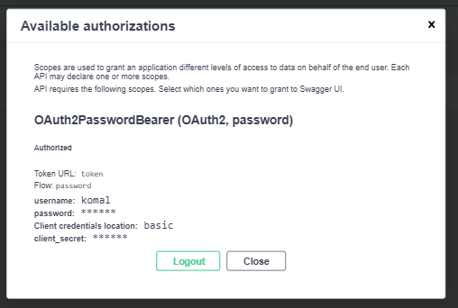

In SWAGGER test your endpoint by clicking on the GET / Root route and then clicking execute.

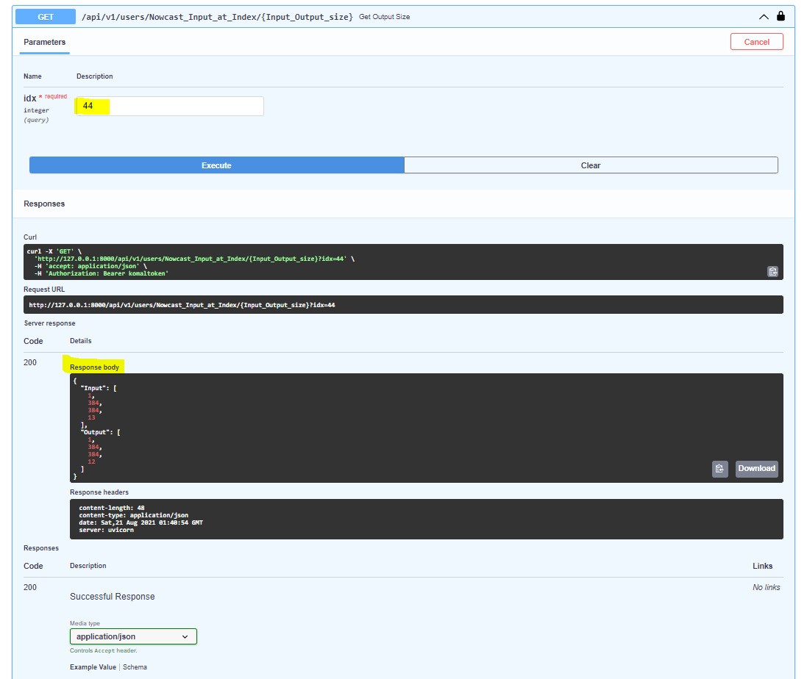

Zip Site package along with the app

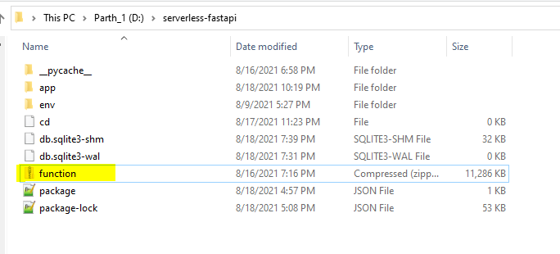

**cd env/lib/python3.7/site-packages**

Inside your terminal from the root directory of your project, CD into the Python Site Packages folder.

**cd env/lib/python3.7/site-packages**

Then zip up the contents into the root of the project.

**zip -r9 path/to/root/of/project/function.zip**

CD back into the root of the project.

**cd path/to/root/of/project**

Next we need to add the contents of the app folder so let's add that into the zip file.

**zip -g ./function.zip -r app**

# Deploy Swagger to Cloud

### Upload Zip File to S3



### Create AWS Lambda

* Navigate to Lambda and click Create Lambda
* Author from scratch and add a name
* Select Python 3.7 Runtime
* Choose or create an execution role
* Create new role using the default is fine.

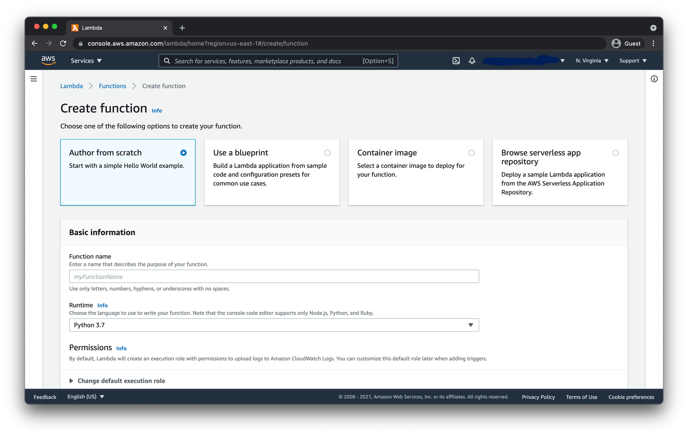

Next we need to upload the zip file from S3. For this we will need the path to the zip file in our S3 bucket. So go to your zip file and check the tick box next to it and click copy path.



Now back in the Lambda dashboard for your function click the Actions dropdown and select Upload a file from Amazon S3.

### Update Handler

By default Lambdas will look for the handler to call the function at lambda_function.lambda_handler So we need to change this to match FastAPI.

Under the Basic Settings menu click Edit then update the Handler to app.main.handler

### Test FastAPI Lambda

Click the Test button at the top of the dashboard and the select the Event Template dropdown and search for API Gateway Proxy.

This test is going to simulate API Gateway invoking the Lambda on a request to our API. So in the JSON document provided we need to update the path and httpMethod key value pairs from the following:

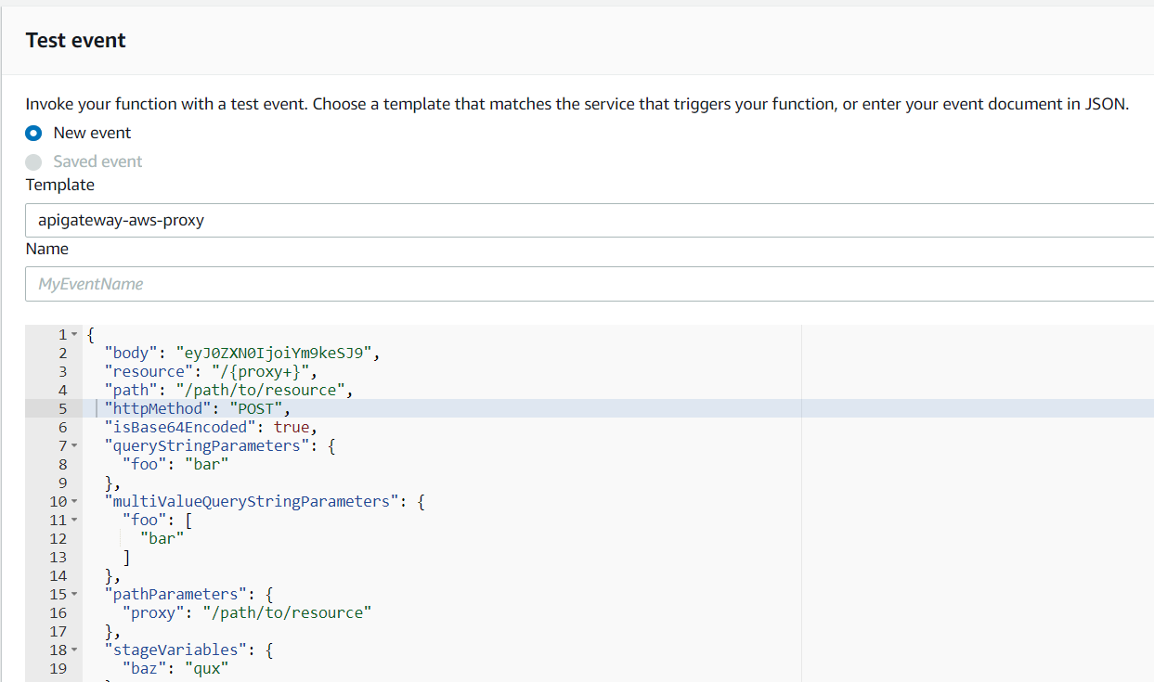

To this

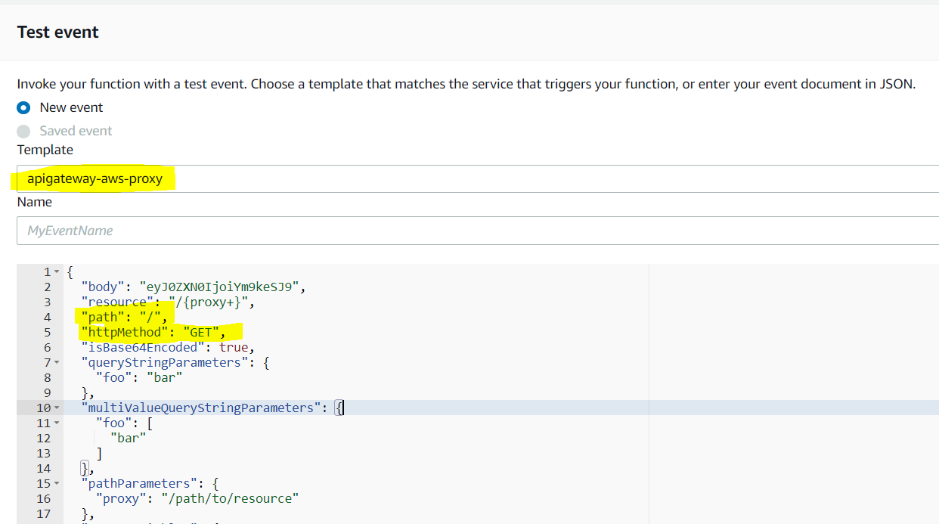

Once you have updated the JSON file go ahead and click Create then click the Test button again.



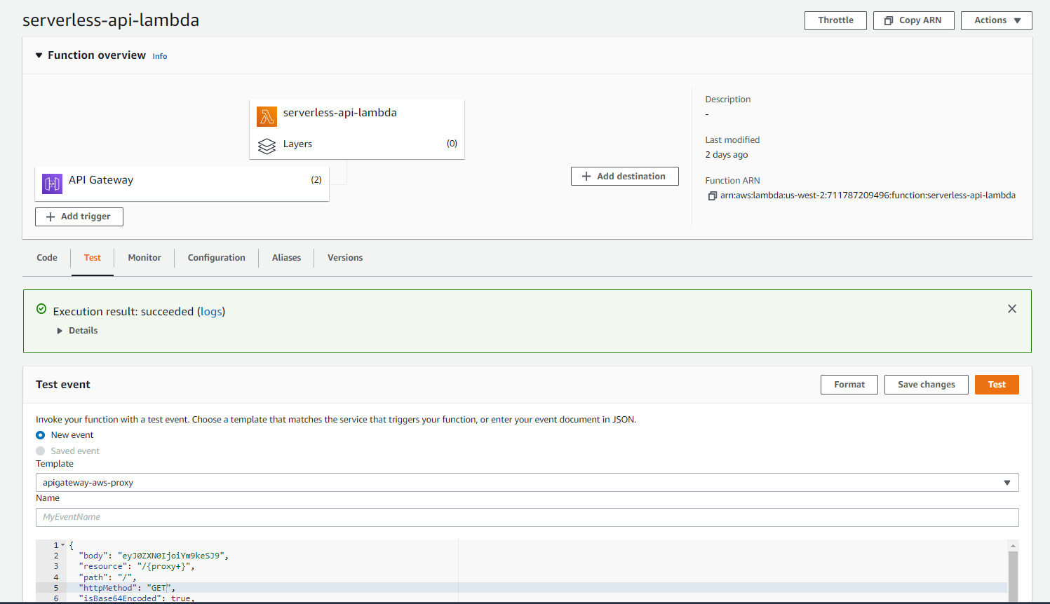

### **Create API Gateway**

Make a public REST API, Navigate to API Gateway and then click the Build button under the REST API option that DOES NOT say "private".

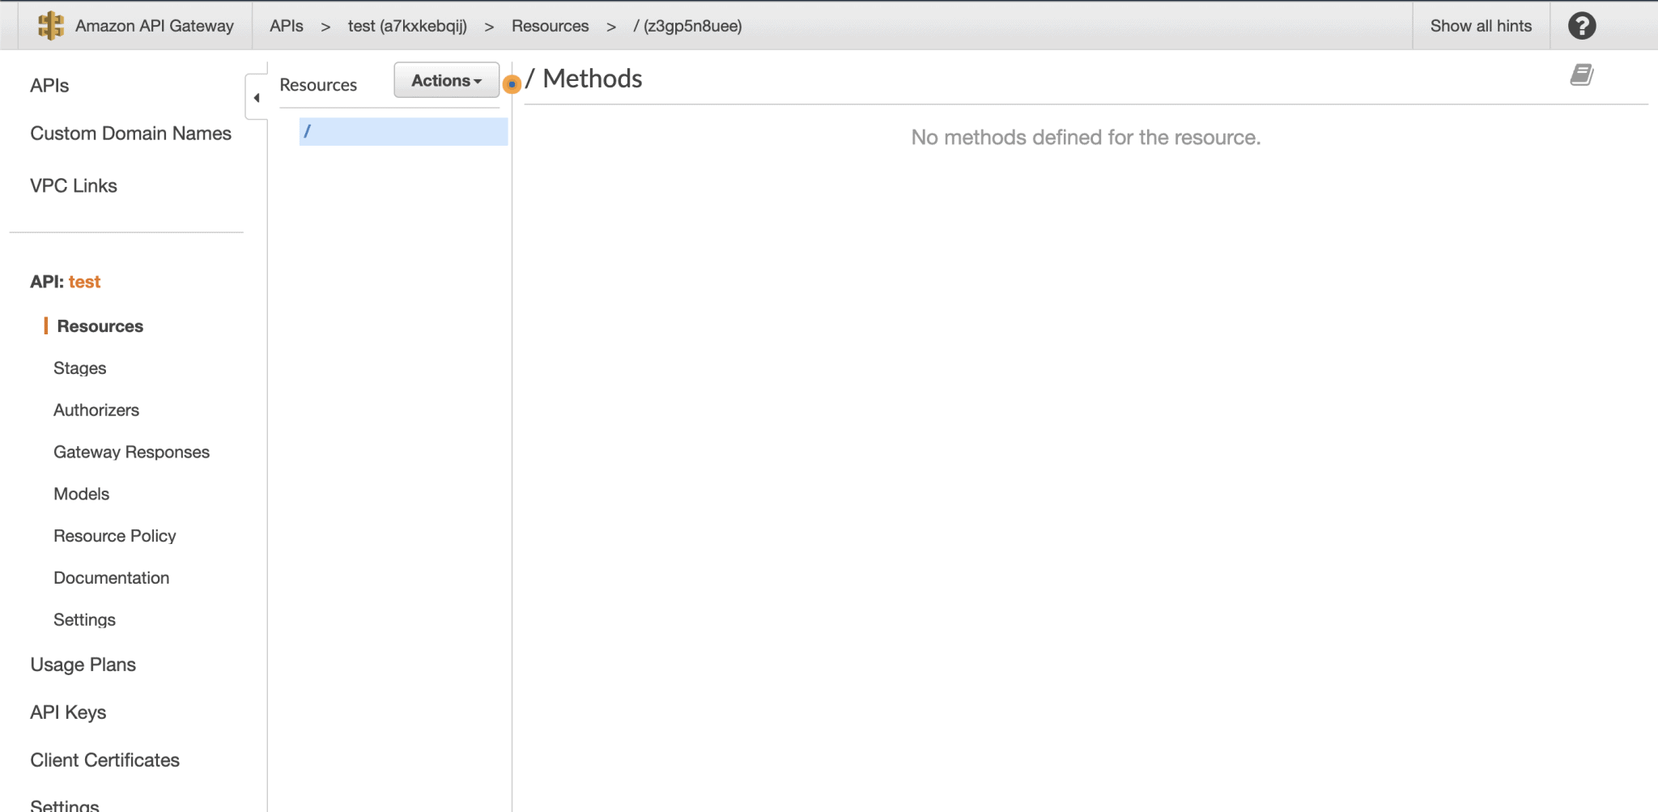

### Create Root Proxy Method

Next the Root Proxy Method will handle forwarding all requests with the base path of / to our FastAPI Lambda.

Navigate to API Gateway and Click on the Resources menu item in the left-hand sidebar.

1. Select Create Method in the Actions dropdown
2. Select ANY from the prompted dropdown and then click the check mark.
3. Check use Lambda Proxy Integration and enter the Lambda Function name and click Save.
4. Add permission to Lambda function click OK.



### Create Resource

Next the following Resource or endpoint weneed to make will handle all other requests.

So if you add a new route to FastAPI like /posts API Gateway will forward the request to the Serverless FastAPI Lambda the same as if it was / or any other path /dev/v1

1. Click on resources and select Create Resource from the Actions dropdown
2. Check Configure as proxy
3. This should automatically add the /{proxy+} to the Resource Path but if not make sure you add it in there.
4. Add Lambda Function Name and leave everything else as default and click Save
5. It will prompt you to add permission to Lambda function click OK.

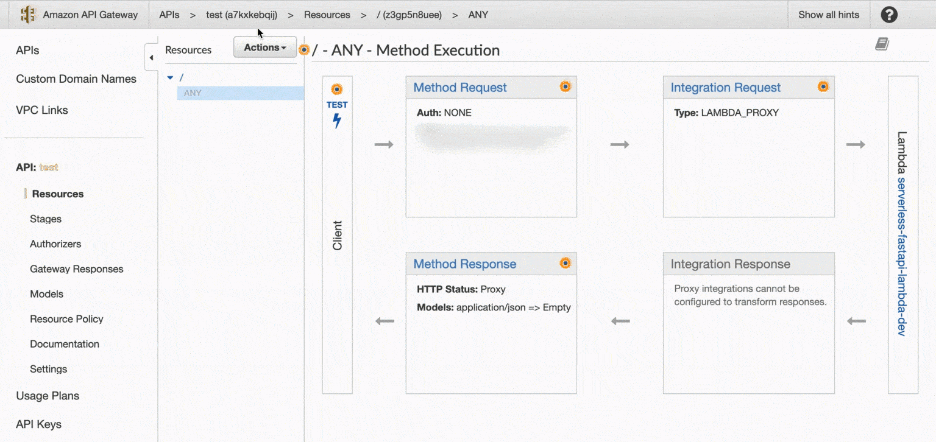

### Deploy Lambda Proxy API

Finally deploy the API in order for the endpoint to be public.

1. Select Deploy API from the Actions dropdown
2. Select New Stage from Deployment Stage dropdown
3. Name it and click Deploy

You will then be taken to the Stage dashboard and you can access your newly deployed Serverless FastAPI with AWS Lambda by clicking the **Invoke URL** link!

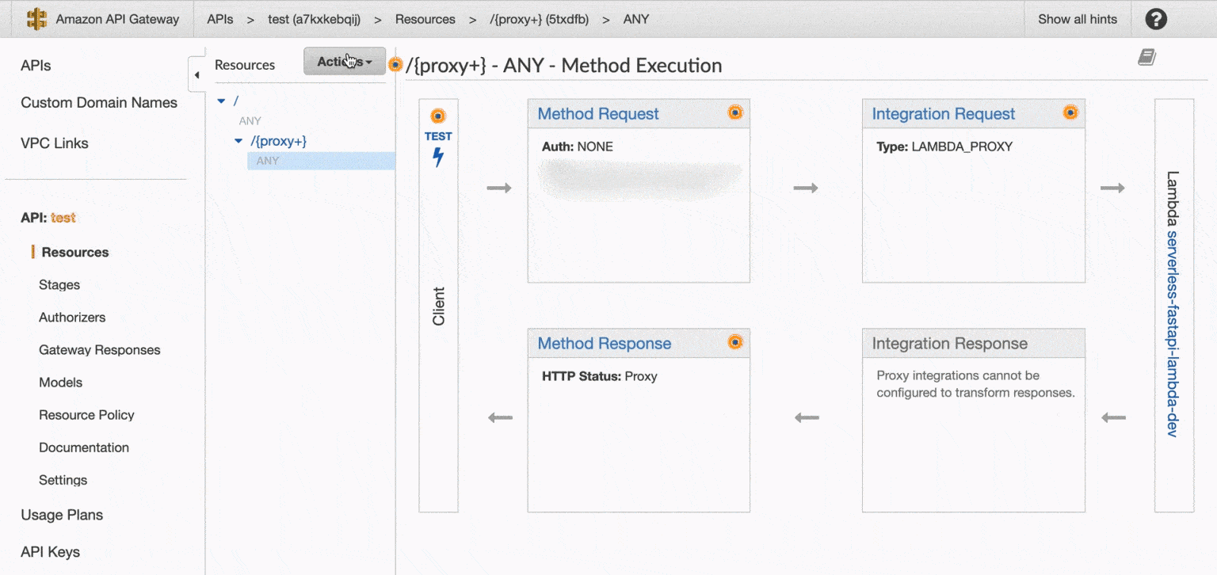

## 

## **We Created a FastAPI application and converted it to an AWS Lambda. Then we setup API Gateway to route all requests to our Lambda proxy-**

Invoke URL:

[**https://ax7ifmckyc.execute-api.us-west-2.amazonaws.com/dev**](https://ax7ifmckyc.execute-api.us-west-2.amazonaws.com/dev)

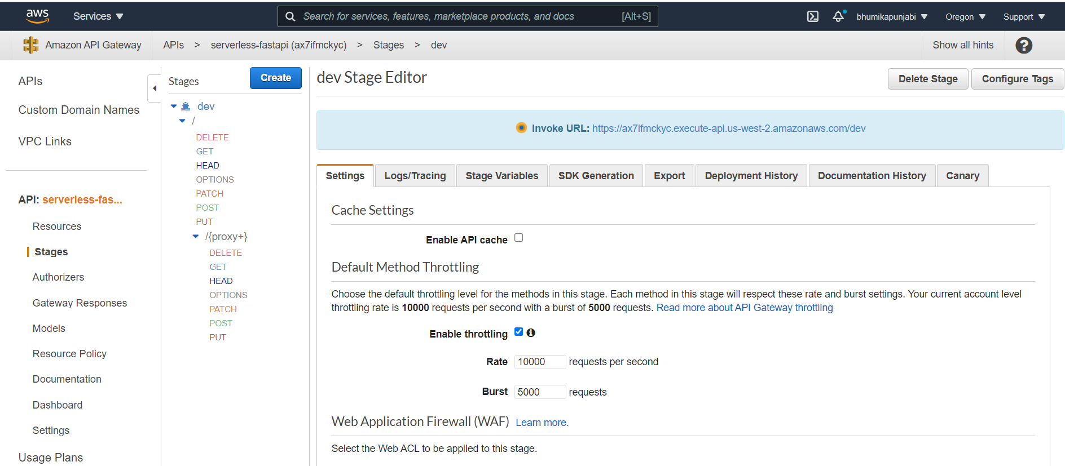

# Swagger- Test the deployed url

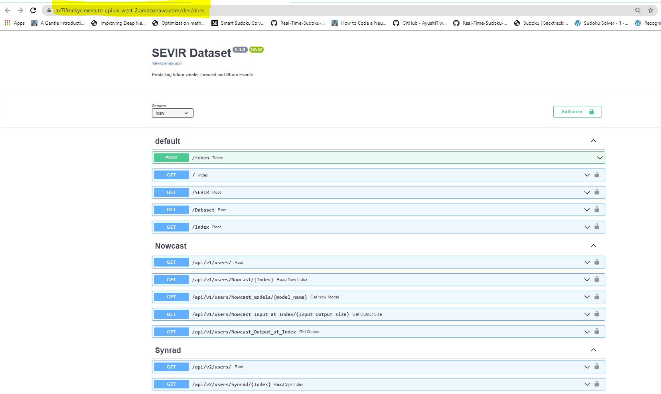

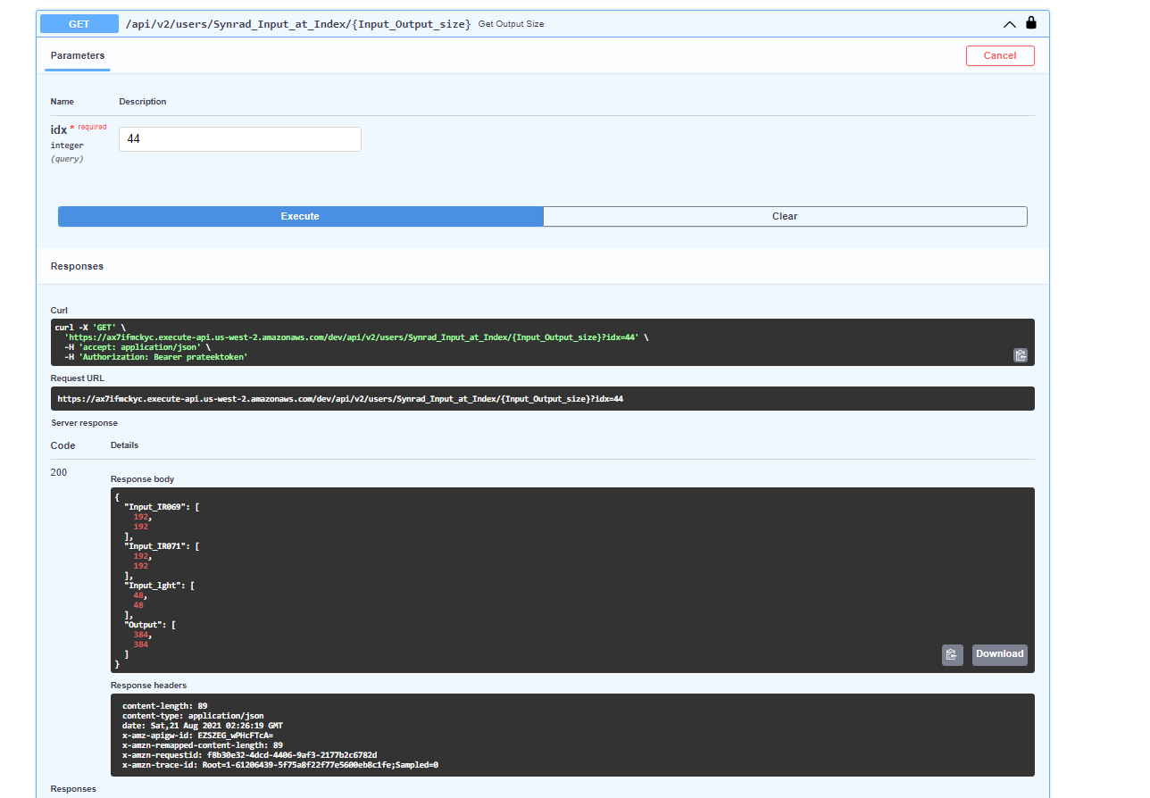

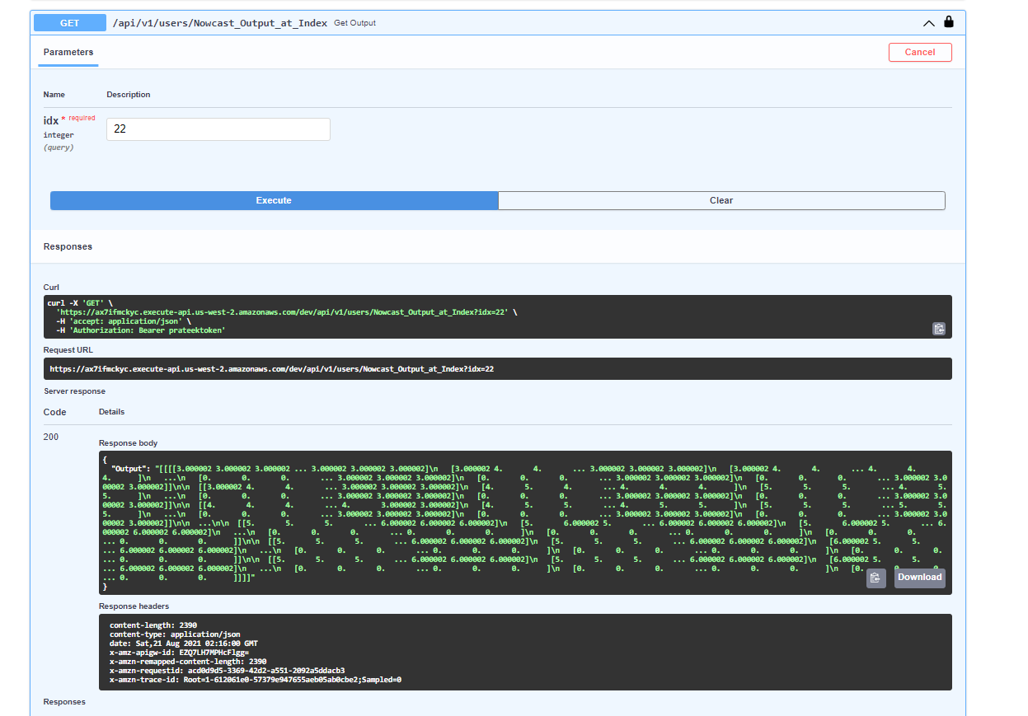

## Postman

GET- [https://ax7ifmckyc.execute-api.us-west-2.amazonaws.com/dev](https://ax7ifmckyc.execute-api.us-west-2.amazonaws.com/dev/token)

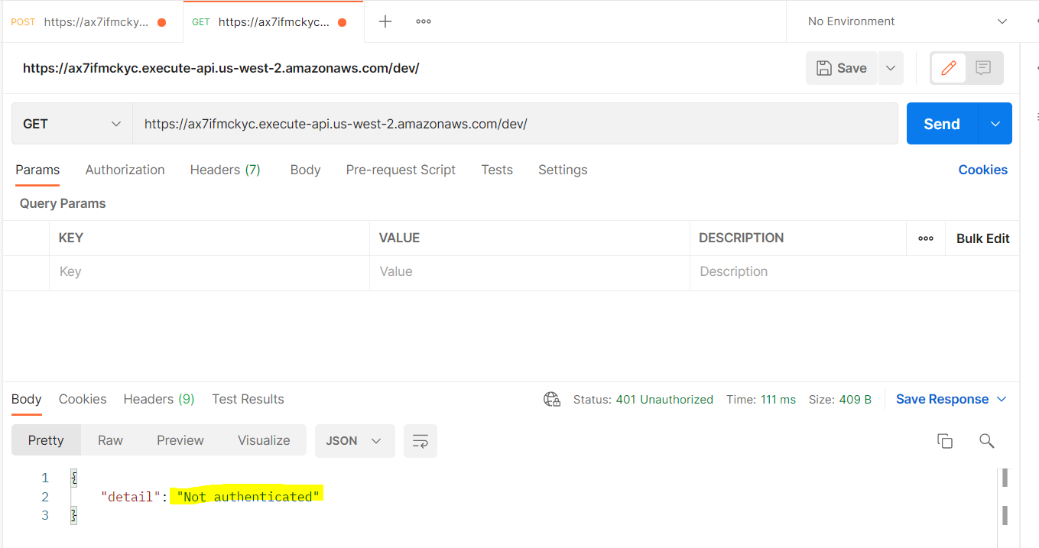

**POST-** <https://ax7ifmckyc.execute-api.us-west-2.amazonaws.com/dev/token>

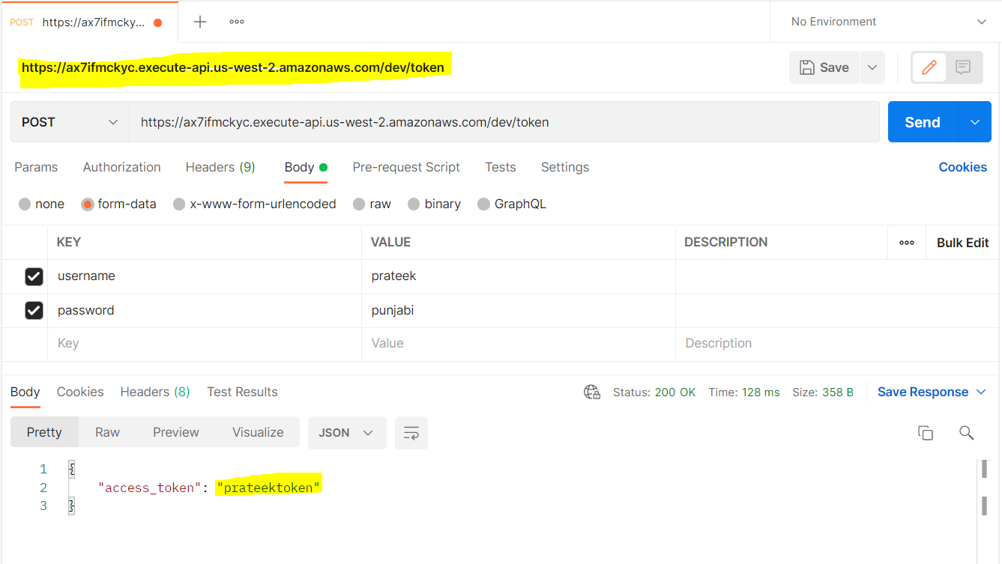

GET- <https://ax7ifmckyc.execute-api.us-west-2.amazonaws.com/dev/SEVIR>

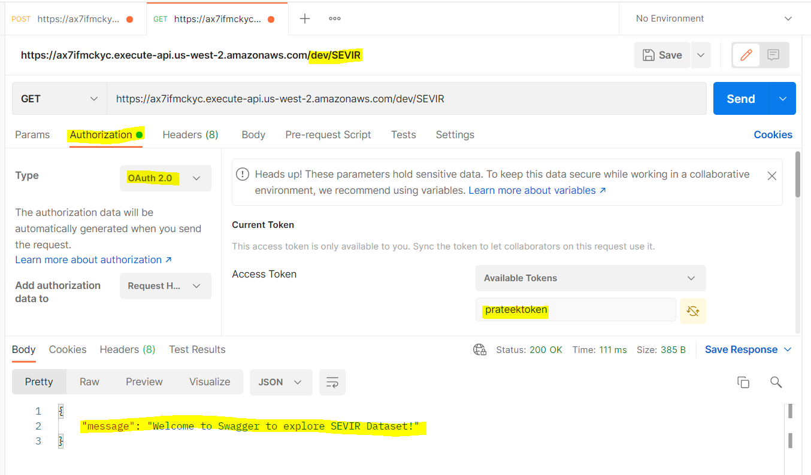

GET- <https://ax7ifmckyc.execute-api.us-west-2.amazonaws.com/dev/api/v1/users/Nowcast_Output_at_Index?idx=22>

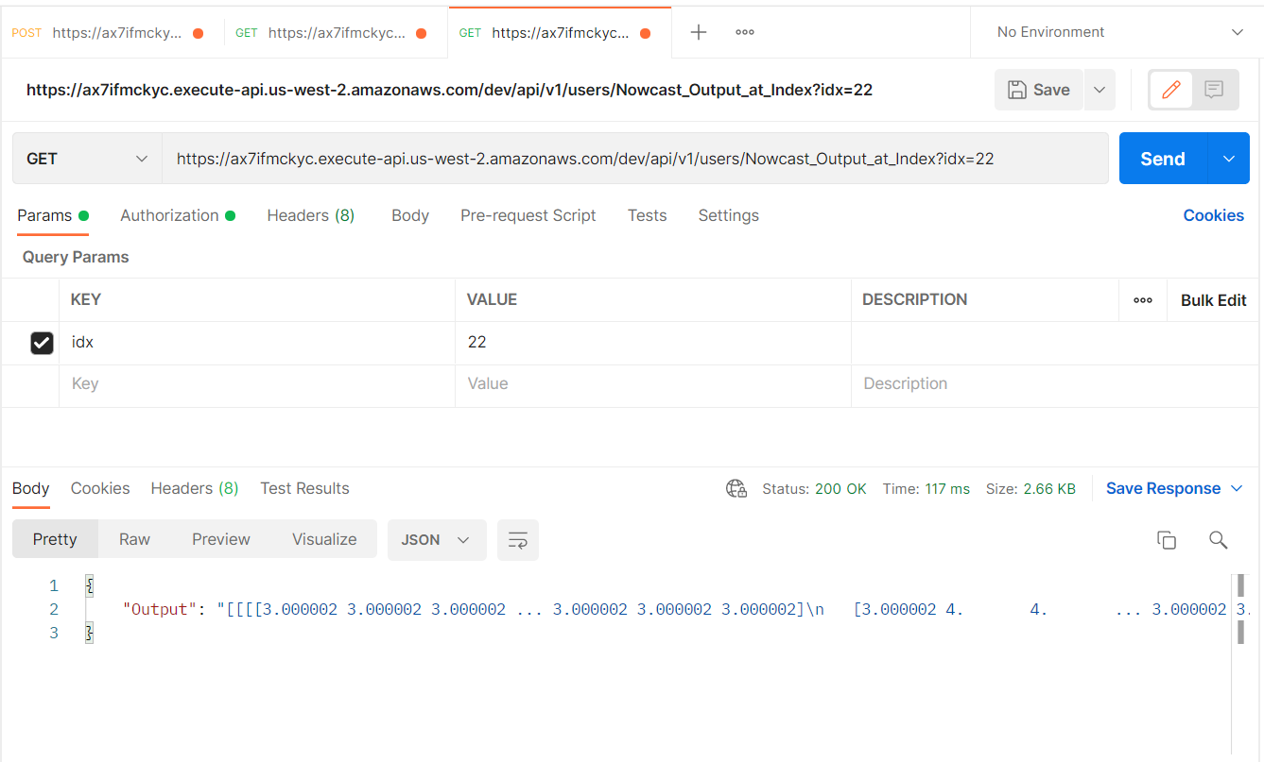

## Test on Web-

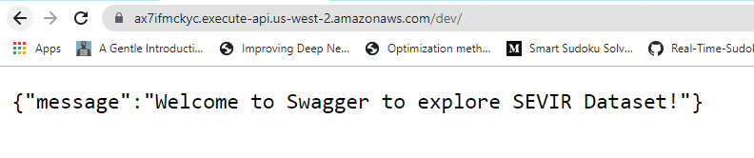

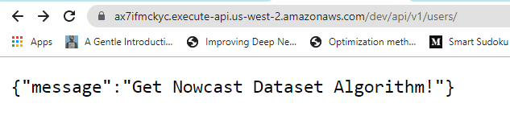

# Streamlit Integration

## Inferenceof Data generated

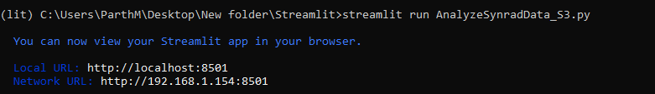

## Nowcast Data Inference

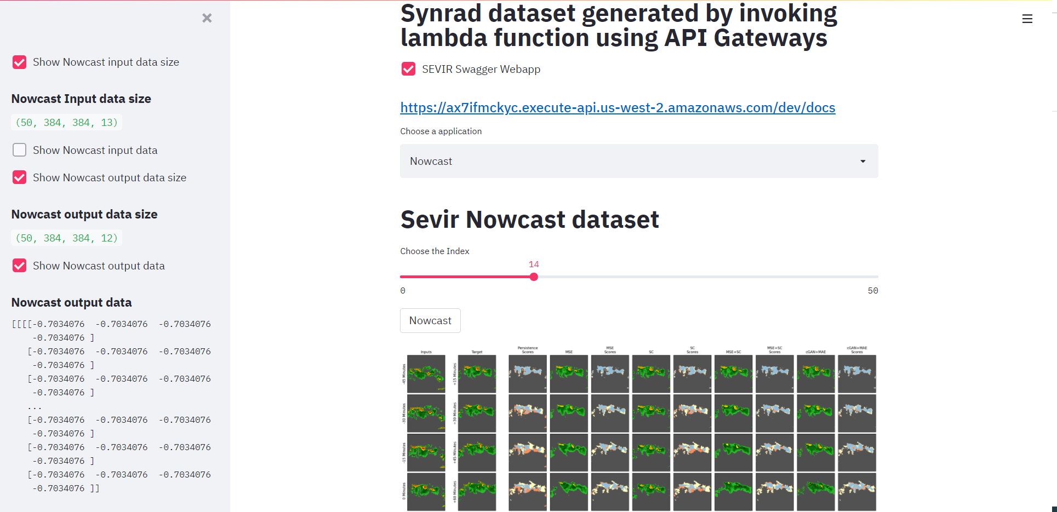

## Synrad Data Inference

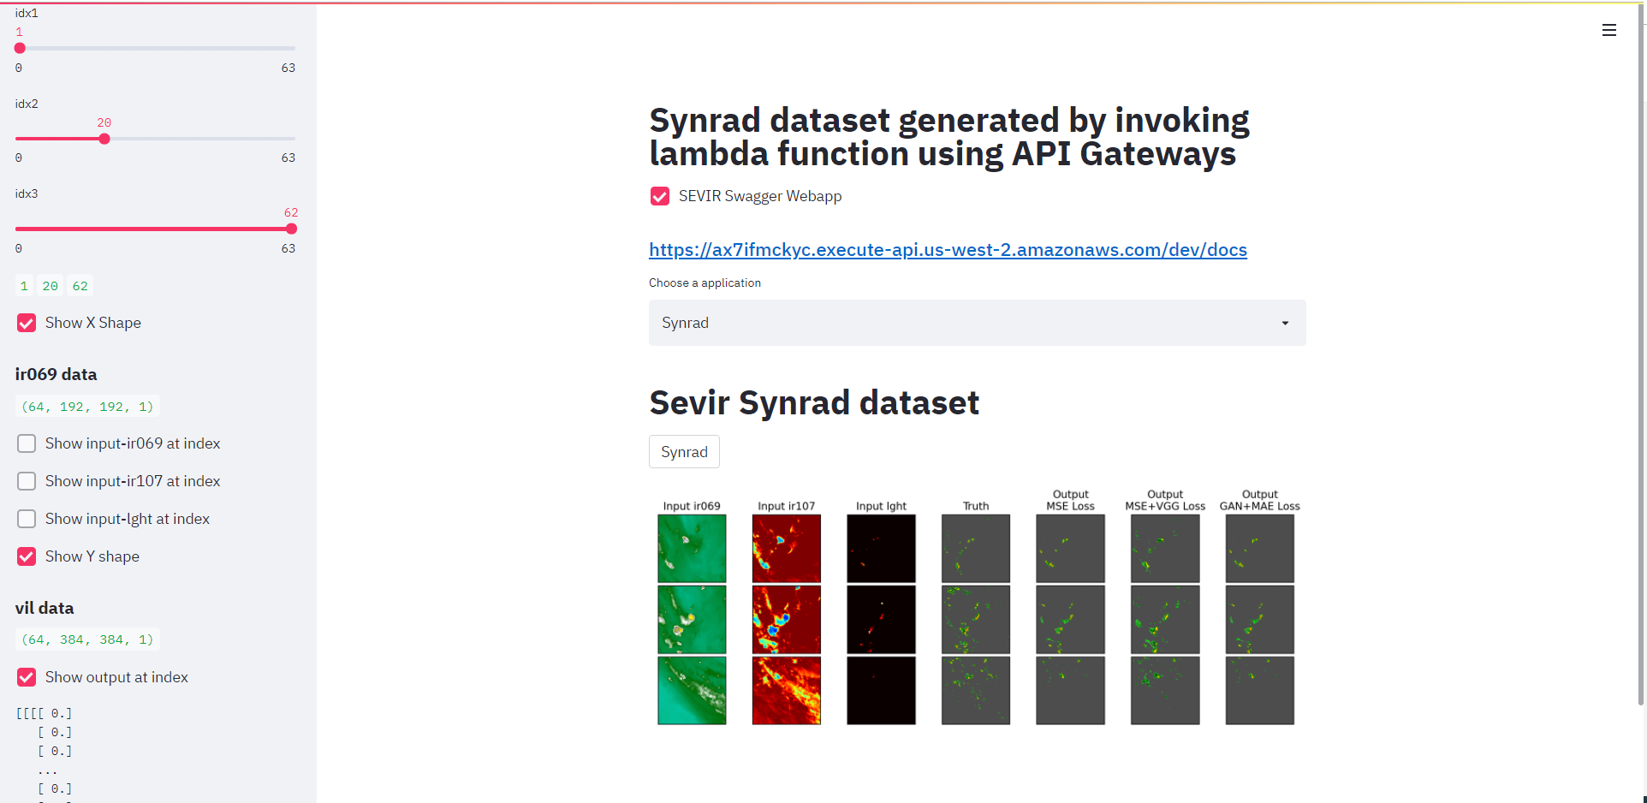

### Code-

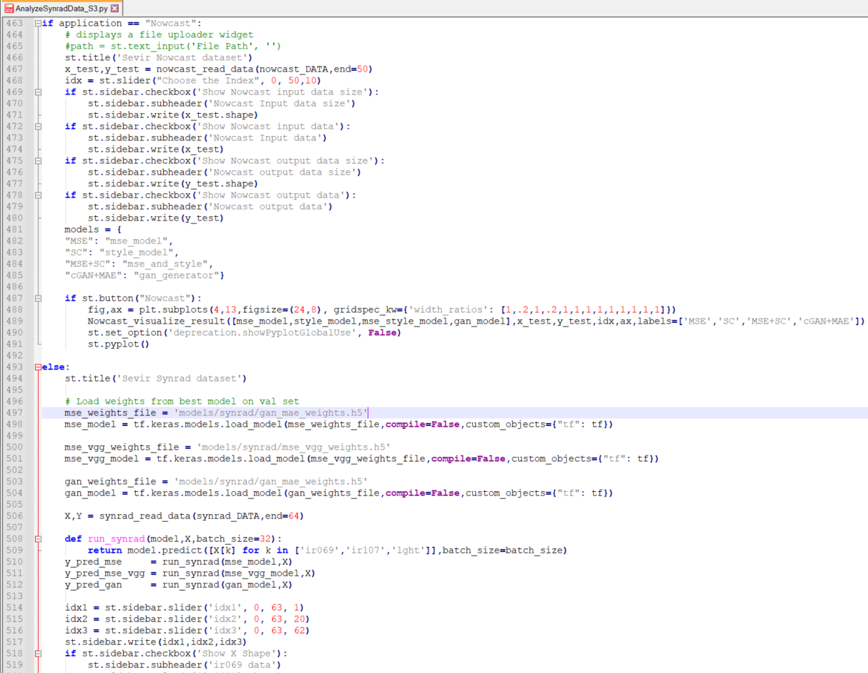

# Deploying Streamlit app to EC2 instance

EC2 is an elastic cloud compute that acts as a virtual server that operate in the cloud. Let us see the steps of deploying our streamlit app.

## STEPS

1.Create An EC2 Instance on AWS

2.Configure Our Custom TCP port to 8501/02

3.SSH into Our Instance/AMI

4.Setup our python environment and run

5.Keeping the App Continuously Running

6. Configure a custom domain name

### Create An EC2 Instance

An instance is a virtual server for running applications.



Choose Amazon Linux AMI 2018.03.0(has python already installed), as Amazon Machine Image.

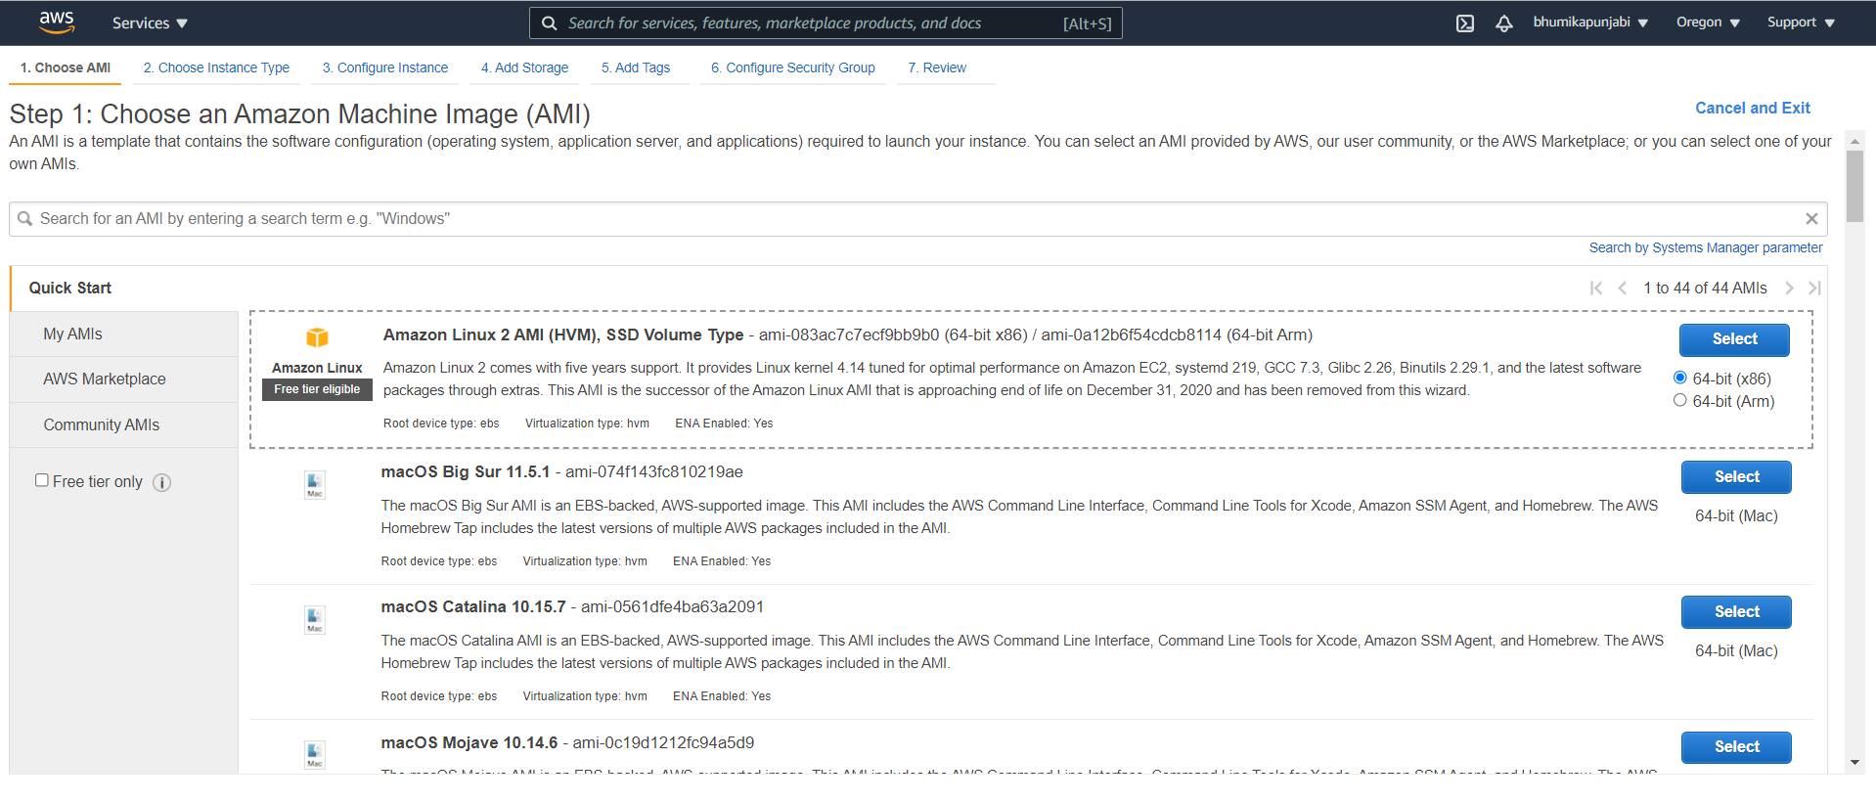

Then for the instance type we will choose the t2.micro as below

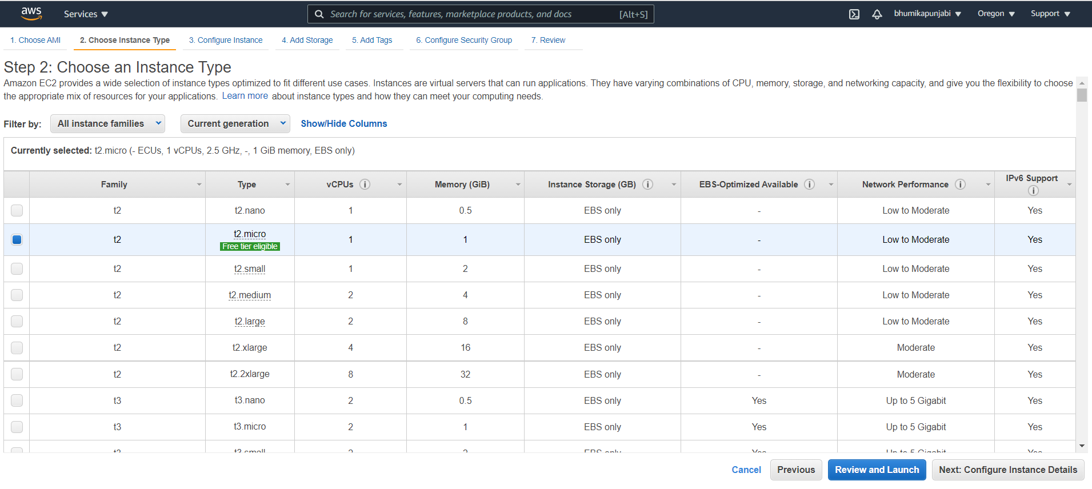

Configure Security Group tab and add custom TCP rule for 8501,8502 port range and select ‘Anywhere’ source to host more than one app at the same time on this instance.

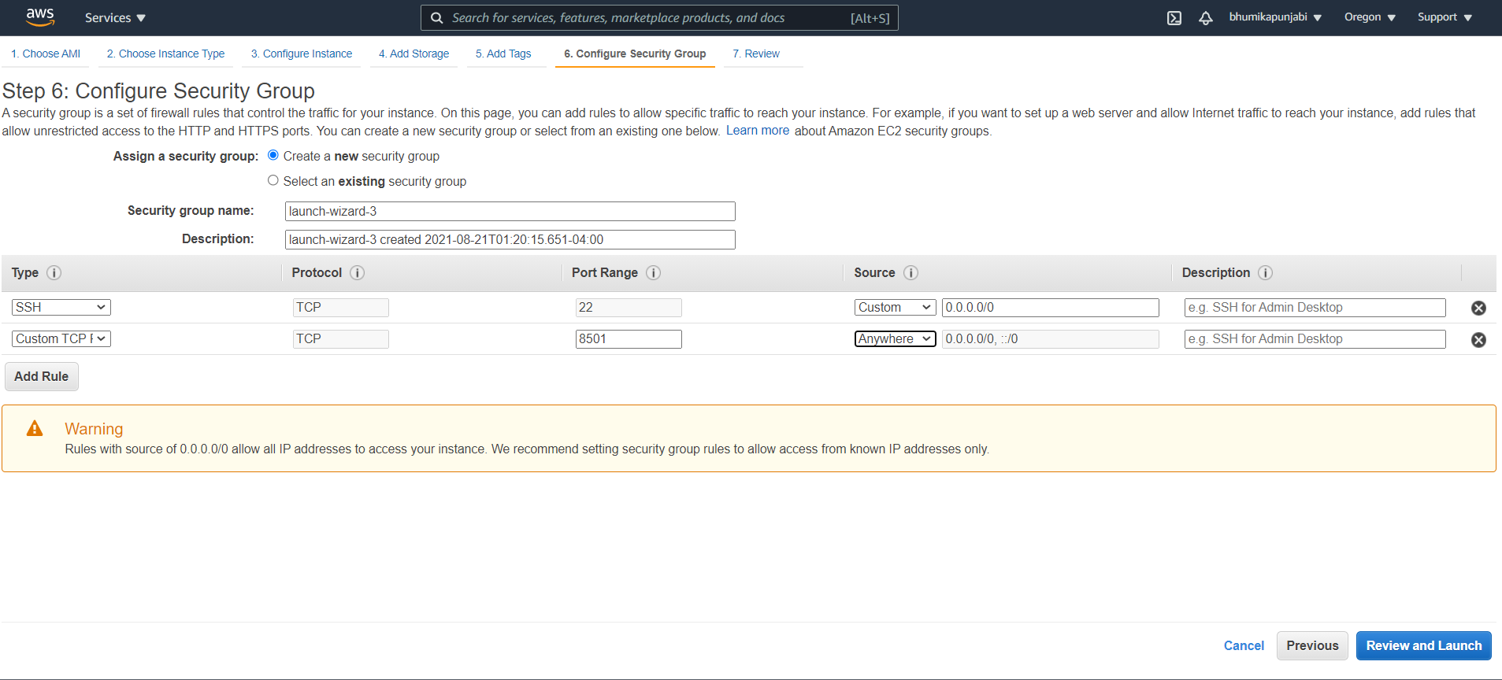

Review and launch and further create key pair and download .pem file.

### **SSH Into Our Instance**

For windows users use putty and puttygen to gain access and change the permissions on .pem file using

chmod 400 your_key_pairs.pem

**SSH**

ssh i your_key_pairs.pem ec2-user@your_public_dns_address

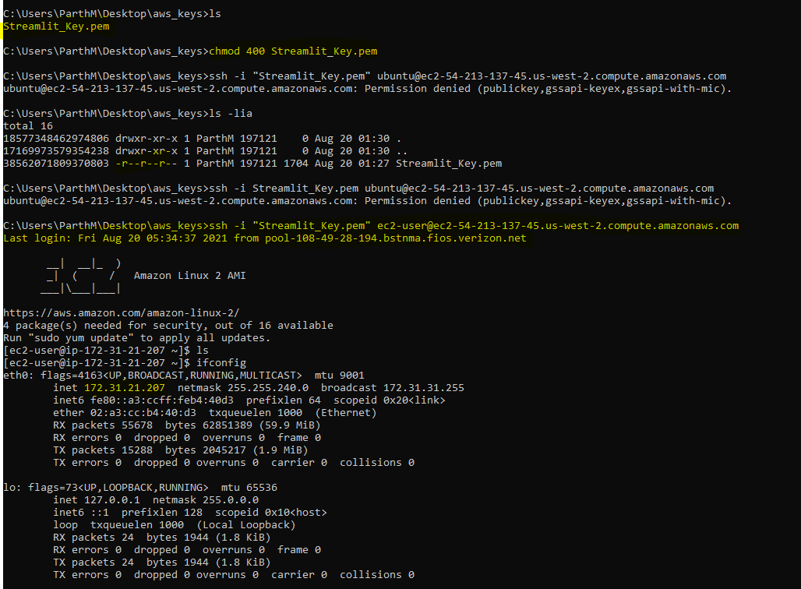

Now linux instance is running in the cloud.

### **Find EC2 Instance Public DNS**

Open the AWS Instances window in the EC2 Management Console.

The Public DNS of your EC2 instance displayed in this window will be used in the [Transferring Files Using WinSCP](https://asf.alaska.edu/how-to/data-recipes/moving-files-into-and-out-of-an-aws-ec2-instance-windows/#winscp) section and the [Transferring Files Using PuTTY Secure Copy (PSCP)](https://asf.alaska.edu/how-to/data-recipes/moving-files-into-and-out-of-an-aws-ec2-instance-windows/#putty_secure_copy) section.

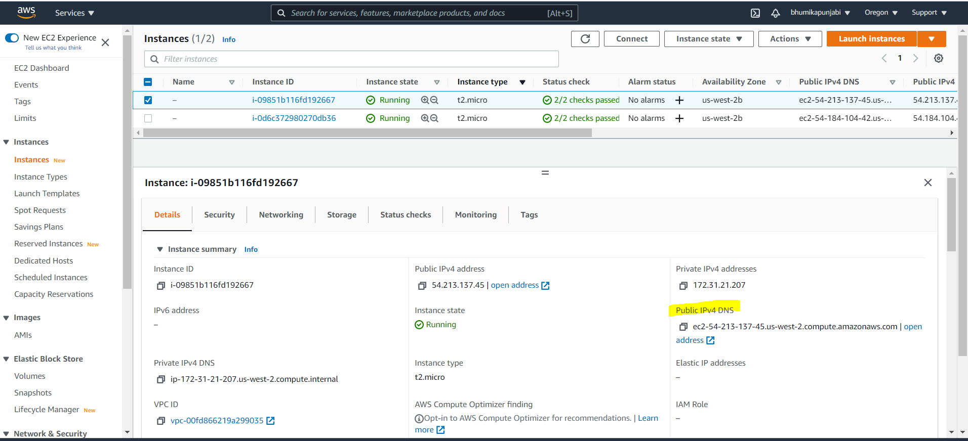The AWS EC2 Management Console.

### **Transferring Files Using WinSCP**

Download and install WinSCP.  
Click on New Site

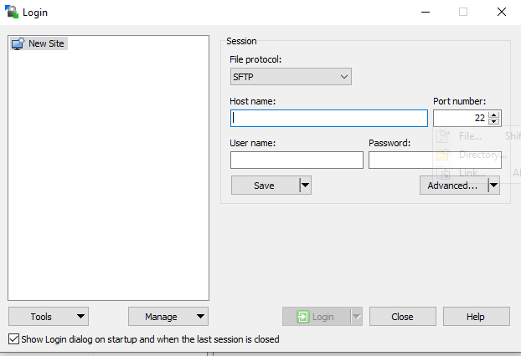

In the Host name box , enter the Public DNS displayed in your EC2 Management Console Instances window, in the User name box type “ec2-user.”

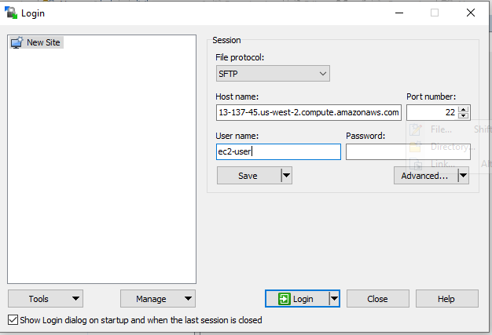

Click on the Advanced button, under Advanced Site Settings window, navigate to SSH , click on Authentication and Under Private key file, click on the button and navigate to the folder where your PuTTY Private Key (.ppk) file is located, and select the .ppk file.

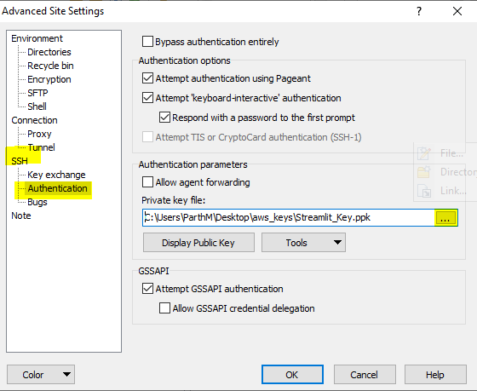

Click on the OK button to close the Advanced Site Settings window, and transfer the Streamlit files to run it on EC2 instance.

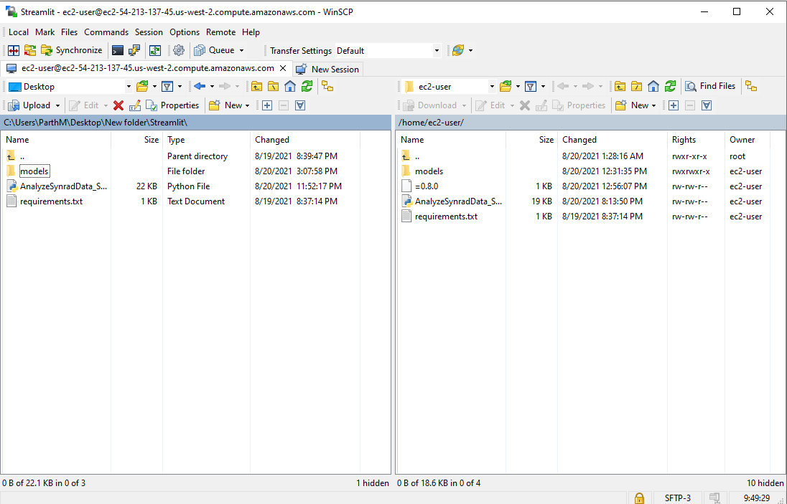

### The next step is to install python, pip3 and all the necessary libraries for your app:

**sudo yum install python36**

**sudo alternatives — set python /usr/bin/python3.6**

**sudo yum install pip3**

### Install all required packages:

**pip3 install pandas**

**pip3 install streamlit**

### Now you simply run your app:

**streamlit run AnalyzeSynradData_S3.py**

Access the app from the external IP address provided by Streamlit interface.

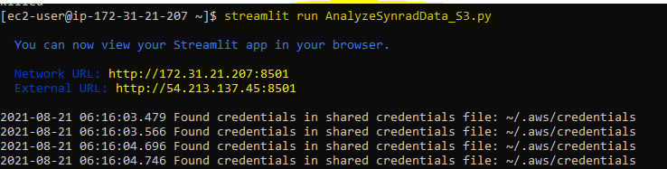

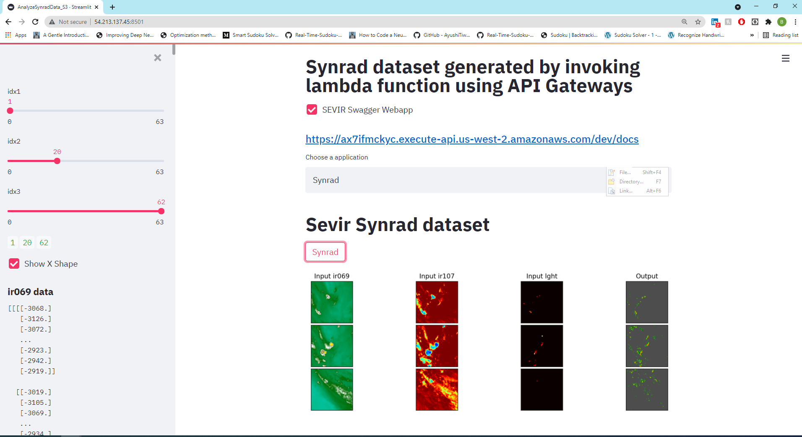

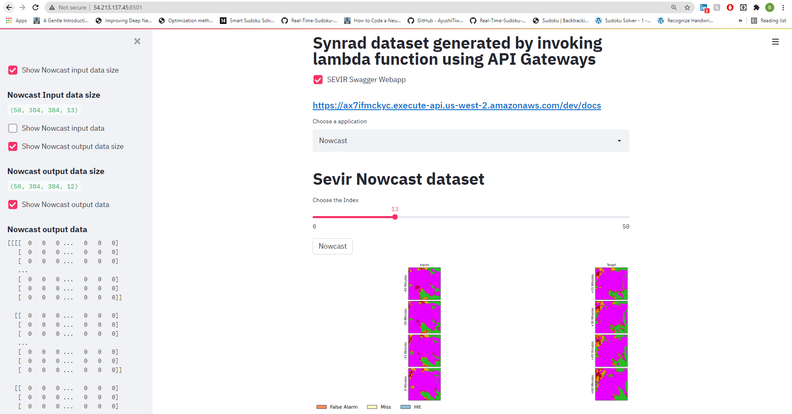

However in order to keep the app running even after you close terminal and disconnect from the instance you need to use TMUX.

First install it:

**sudo yum install tmux**

And after installing it create new window:

**tmux a -s mywindow**

There you run streamlit app:

**streamlit run AnalyzeSynradData_S3.py**

This way the app is hosted even after you close the terminal, so this will kind of work like AWS

If you want to shut down hosted app open terminal with AWS instance (via Putty) and go to the window

**tmux a -t mywindow**

And kill the running Streamlit app.

# Github URL-

<https://github.com/bhumikiapunjabi2294/BigData>

<https://github.com/bhumikiapunjabi2294/Streamlit>

# References

* <https://fastapi.tiangolo.com/deployment/versions/>
* <https://towardsdatascience.com/create-your-first-rest-api-in-fastapi-e728ae649a60>
* <https://www.educative.io/blog/python-fastapi-tutorial>
* <https://codingnomads.co/blog/python-fastapi-tutorial>
* <https://github.com/tiangolo/fastapi>
* <https://www.deadbear.io/simple-serverless-fastapi-with-aws-lambda/>
* <https://www.deadbear.io/serverless-fastapi-ci-cd-with-circleci/>
* <https://towardsdatascience.com/build-with-pycaret-deploy-with-fastapi-333c710dc786>
* <https://realpython.com/fastapi-python-web-apis/>
* <https://developer.okta.com/blog/2020/12/17/build-and-secure-an-api-in-python-with-fastapi>
* <https://github.com/PrettyPrinted/youtube_video_code/tree/master/2021/01/05/FastAPI%20Authentication%20Example%20With%20OAuth2%20and%20Tortoise%20ORM/fastapiauth>
* <https://www.youtube.com/watch?v=6hTRw_HK3Ts&ab_channel=PrettyPrinted>
* <https://towardsdatascience.com/how-to-deploy-a-streamlit-app-using-an-amazon-free-ec2-instance-416a41f69dc3>
* <https://github.com/MLWhiz/streamlit_football_demo>
* <https://medium.com/@pokepim/deploying-streamlit-app-to-ec2-instance-7a7edeffbb54>
* <https://hersanyagci.medium.com/model-deployment-with-streamlit-on-aws-ec2-f52ab42d7813>
* <https://blog.jcharistech.com/2019/10/29/how-to-deploy-streamlit-apps-on-aws-ec2/>